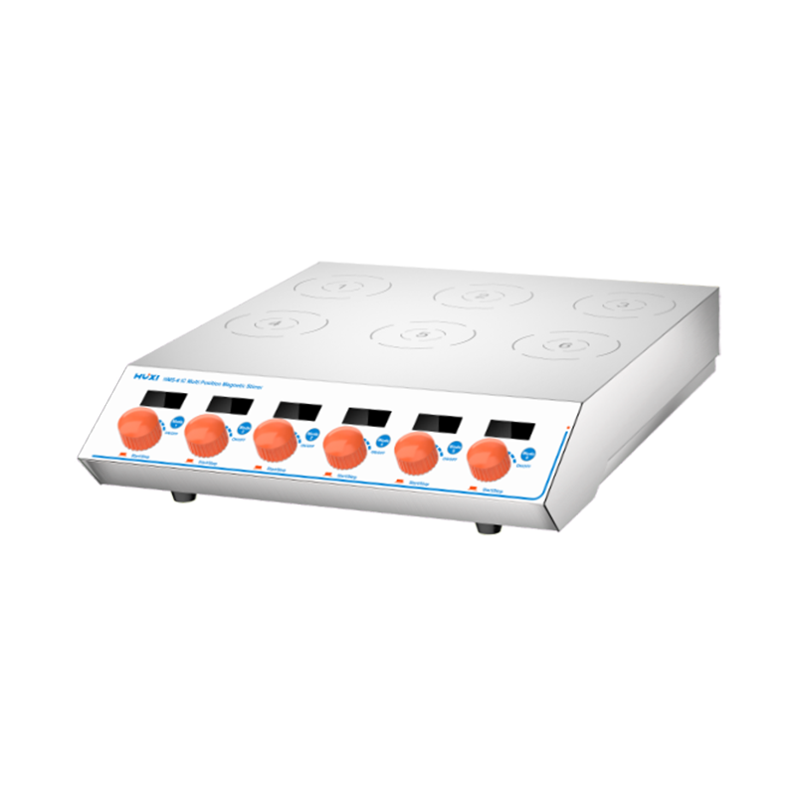

# **HMS-6IC Multi Position Magnetic Stirrer**

**Application：**

HMS-6IC multi-station stirrer has a wide range of models to meet different experimental needs; commonly used for stirring low-viscosity liquids or solid-liquid mixtures, specially designed for colleges and universities, scientific research, environmental protection, chemical industry, biology, pharmaceutical and other industries.

**Main Features：**

* 100~240V wide voltage design, wide range of application;
* With time setting function, adjustable within 0-9999min timing range, high quality non-slip feet are close to the lab bench surface, no gap and smooth running;
* IP64 protection level, providing all-round and angular splash-proof and waterproof protection;
* Individual control for each working station, adjustable time and speed, good starting performance and wide speed adjustment range;
* Adopting 316 stainless steel material, strong and solid, superior corrosion resistance and high temperature resistance;
* DC brushless motor drive, low noise, low maintenance, maintenance-free, long service life;
* LCD liquid crystal display real-time display of speed and time, data intuitive, more accurate reading;
* Standard stirrer with strong magnetic force, stirring effect is remarkable, single-station stirring volume up to 1000ml;
* Speed can be set from 200 to 2200rpm, even at low speed, it can run smoothly.

**Techncial Parameters：**

|  |  |
| --- | --- |
| Model | HMS-6IC |
| Item No. | 1002064001 |
| Mixing Points | 6 |
| Mixing capacity(ml) | 1000*6 |
| Whole power(W) | 32 |
| Control mode | Six Knob |
| Operation mode | Individual control |
| Driver | Motor drive |
| Voltage(V) | 100-240 |
| Frequency(Hz) | 50-60 |
| Noise level(db) | ≤27 |
| Display mode | LCD |
| Shell material | 316 Stainless steel |
| Working plate material | 316 Stainless steel |
| Working distance(mm) | 115 |
| Speed Range(rpm) | 200~2200 |
| Timer Range(min) | 0~9999 |
| Protection class | IP64 |
| Mixing bar range(mm) | ≤20 |
| Allowable ambient humidity（%） | 80 |
| Allowable ambient temperature(℃) | 5-40 |
| Plate size(mm) | 290*360 |
| Instrument Size(mm) | 360*360*75 |
| Packing Size(mm) | 460*460*175 |
| NW(kg) | 4.2 |
| GW(kg) | 5 |